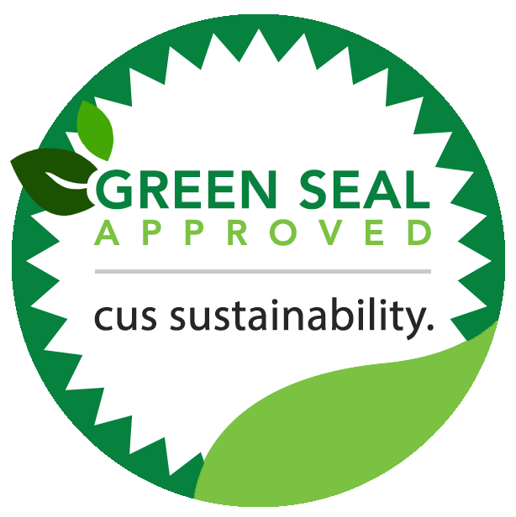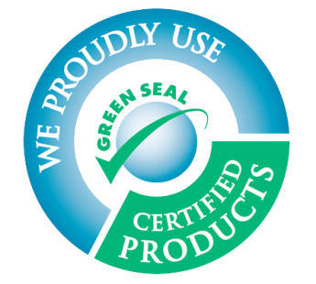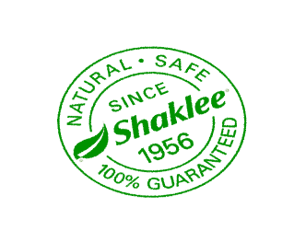
Shaklee’s product meets Green Seal’s environmental standard for industrial and institutional cleaners based on its reduced human and aquatic toxicity and reduced smog production.
Green Seal is and an independent nonprofit organization, well recognized for awarding certification to products that proves to be environmentally preferable and effective after scientific evaluation.For more information on Green Seal visit: www.greenseal.org

